1. **BDD – Behavior Driven Development**

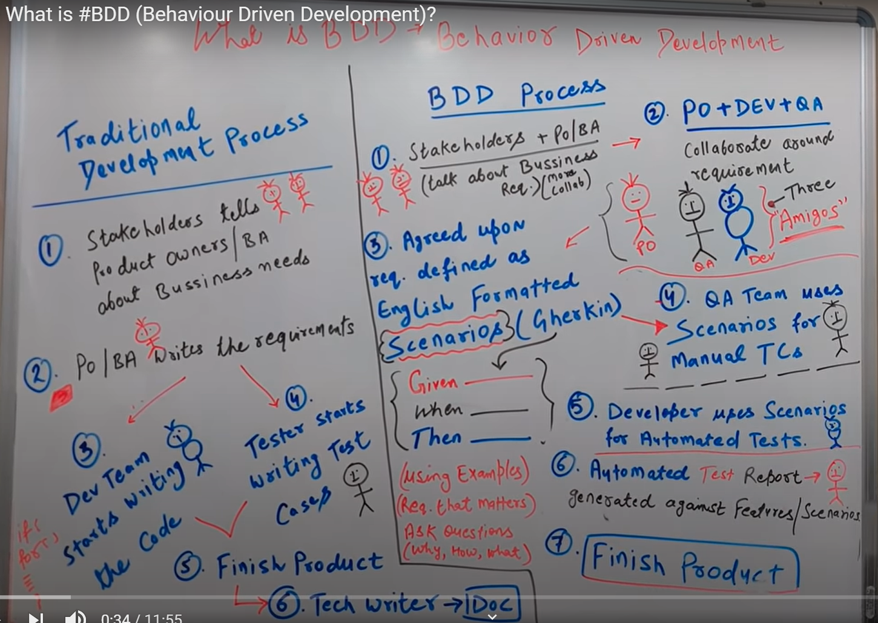

1. **BDD process is not just Cucumber**. BDD is a process that can be implemented in a project running on Agile methodology. Cucumber is an automation testing tool that follows the BDD pattern.
2. A disadvantage of the Traditional software development model is that everyone works independently, BA/PO collects the requirements and developer starts writing code and tester starts writing test cases. The core idea behind BDD to improve the process in a way that everyone brainstorms, asks questions and collaboratively works on the project development.
3. As shown in the above diagram, in a BDD process once the Business and PO/BA sit together to understand the requirements, later these requirements are discussed with the 3 amigos as they are called in BDD (PO+Dev+Test) and based on that they frame the Feature files together.
4. The feature files can be later used by the testing team to write manual test cases and by the automation team to implement automation using cucumber or other similar tools and also by developers to develop the application. Later these Feature files can be used for writing the Product documentation.
5. It is not mandatory that in a BDD process there should be automation testing.

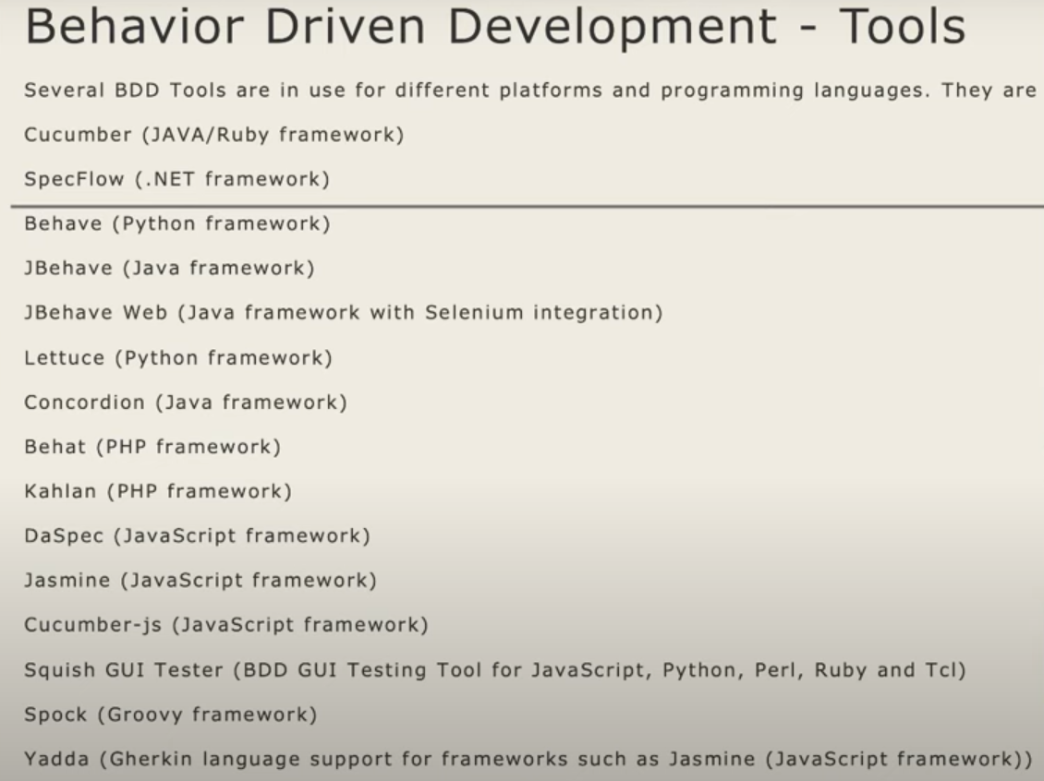

1. **TDD vs BDD vs ATDD** 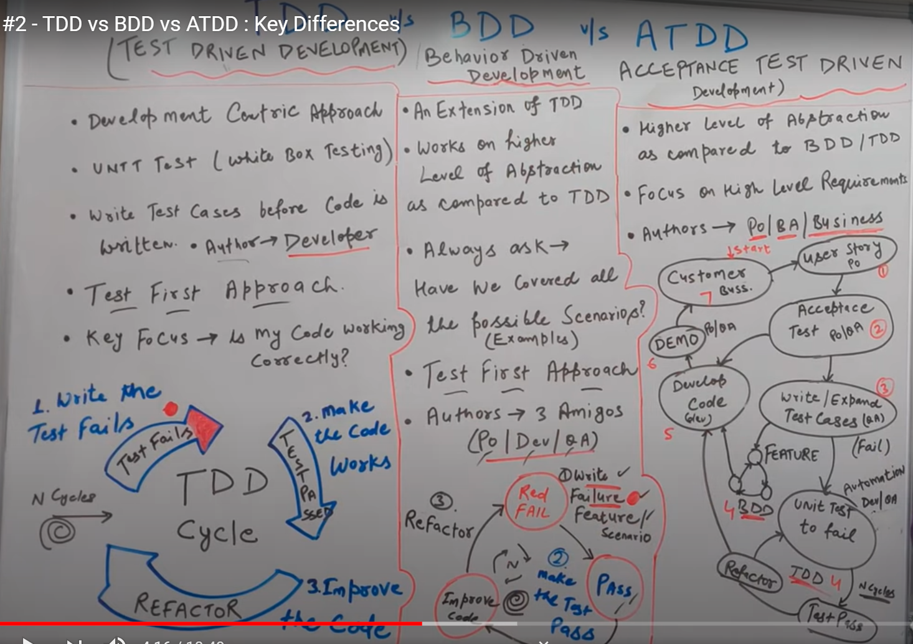
2. **TDD, BDD and ATDD are three best processes** for software development that can be used in an Agile framework.
3. **TDD focuses** on writing the tests first and then running it which would fail first as the code is not there and then implementing the code. Again running the tests and improving the code quality. In TDD approach the author is developer or automation tester.
4. **BDD focuses** on collaborative team effort in which PO, Dev and QA would discuss the requirements and ask questions to develop feature files which can be used in later stages for manual testing or automation/development. TDD is a subset of BDD. In the BDD approach the author is the PO, QA and Dev.
5. **ATDD focuses** more on the high level requirements, here the requirements are analyzed based on the acceptance test and only once confirmed are passed on to the team who can implement the project using either TDD or BDD approach. In ATDD approach the author is PO/BA and business/stakeholder.
6. **Cucumber Tips**
7. Cucumber Java Project Skelton

<https://github.com/cucumber/cucumber-java-skeleton/blob/main/pom.xml>

Reusing this Skelton avoids confusion while creating a new Cucumber project.

1. While passing the data from feature file to step definition, like how String is passed similarly we can pass int, float etc as well.

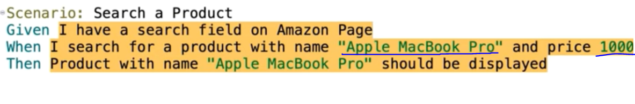

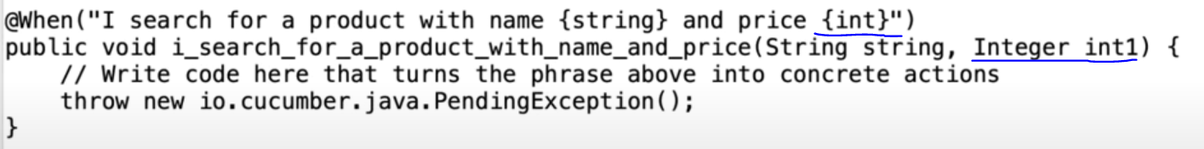

1. While running Feature file using Maven, to get properly readable formatted reports, then the Runner class name must be as below :

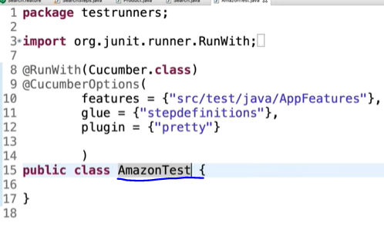 which means that the Class name must end in ‘**Test’**, then only Junit would be able to produce proper output and display it while running with maven.

1. The proper build automation structure for a cucumber project is as below : 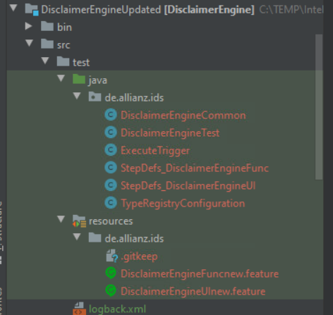
2. **Cucumber Expression vs Regular Expression**
3. Cucumber Step definitions allow the versatility to use either cucumber expressions or regular expressions.
4. **By default** while running a feature file before writing the step definition then in the console only Cucumber expressions would get generated.
5. Cucumber Expression 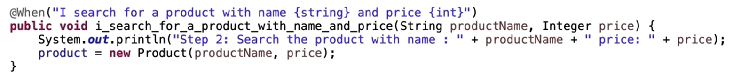
6. Regular Expression 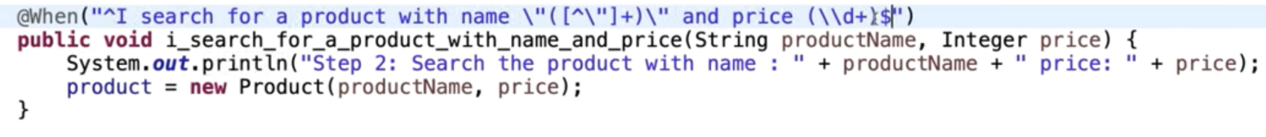

While using regular expression it should start with ^ and end with $

Regular expression is having 2 parts – Quantifiers and Shorthand characters 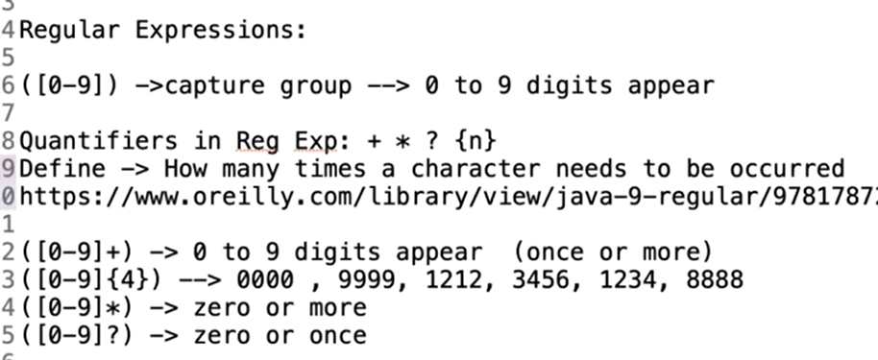

Below are some of the main shorthand characters that are used in regular expression 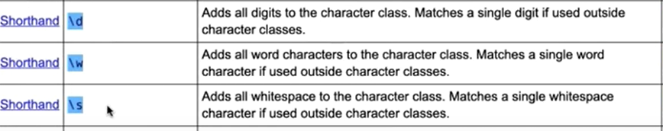

1. In the same Step Definition class there can be one method with Cucumber expression and one method with Regular expression **but** In one method we can’t mix both Cucumber expression and Regular expression
2. Advantage of cucumber expression over regular expression is that **cucumber expressions are simpler to use.**
3. Advantage of regular expression is that it provides a higher level of power to extract a particular value from a feature file.
4. **Cucumber Tags**
5. Cucumber Tags can be applied at feature level or at scenario level but not at tests level (like with given, when, then etc.). 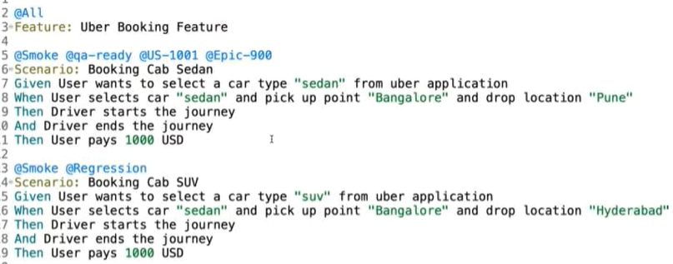

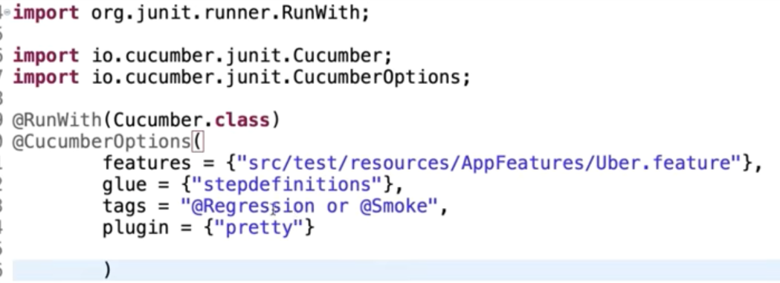

In the above image, we can see that all the scenarios or feature files with either the tag @Regression or @Smoke will run successfully.

1. To execute all the tags except a specific one then we can use ‘not’ operator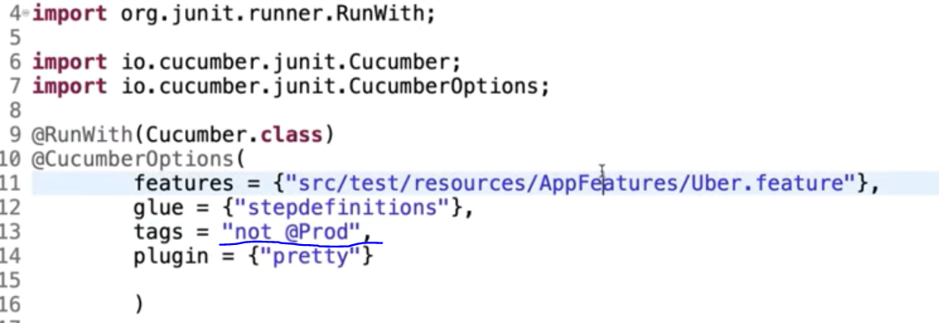
2. To execute tags specifically from maven command line we can use below command from **Cucumber 6 onwards.**

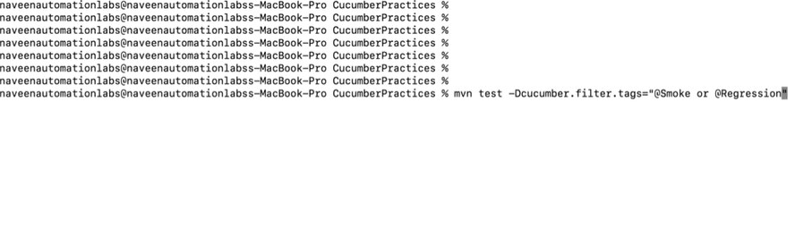

1. **Cucumber Background** 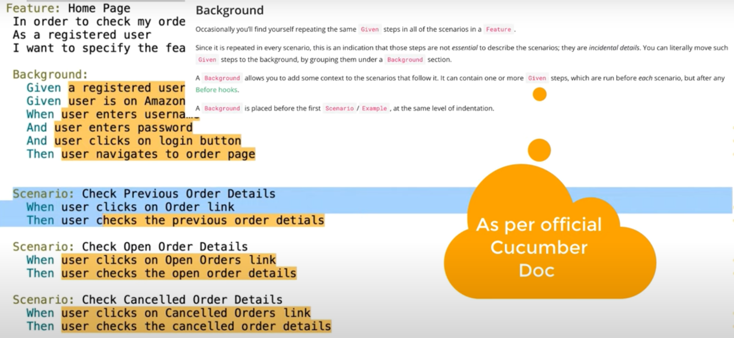
   * Background section is used to group together certain steps which are being followed by all scenarios in a feature file.
   * Background section is repeated before each scenario in a feature file.
   * **Important** – When a feature file has **Before Hooks** and **Background** then Background runs before each scenario but **only after Before Hooks is executed**.
2. **Cucumber Hooks**

* Hooks are not a part of the feature file, it **can be written in Step definition file or it can be written in a separate class**. It is quite similar to the @BeforeMethod and @AfterMethod of testNG.
* **@Before** hook can be used to run before each scenario likewise **@After** hook can be used to run after each scenario.
* **@BeforeStep** hook can be used to run before each step likewise **@AfterStep** hook can be used to run after each step of the scenario. 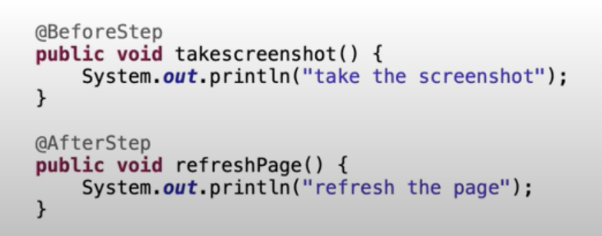
* We can also have multiple hooks at a time and to run them in specific order then we can define the order

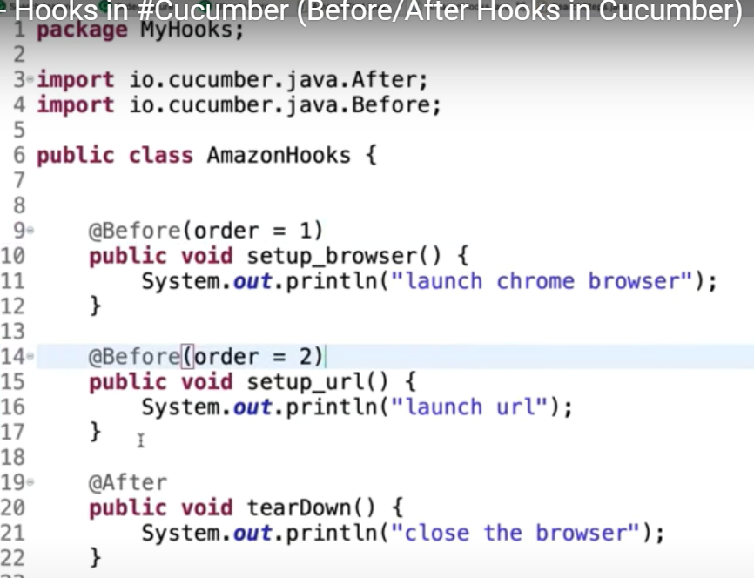

* When writing the hooks in a different class and not in the Step definition, then in the **Runner class** we need to specify the package name of the class in the glue section.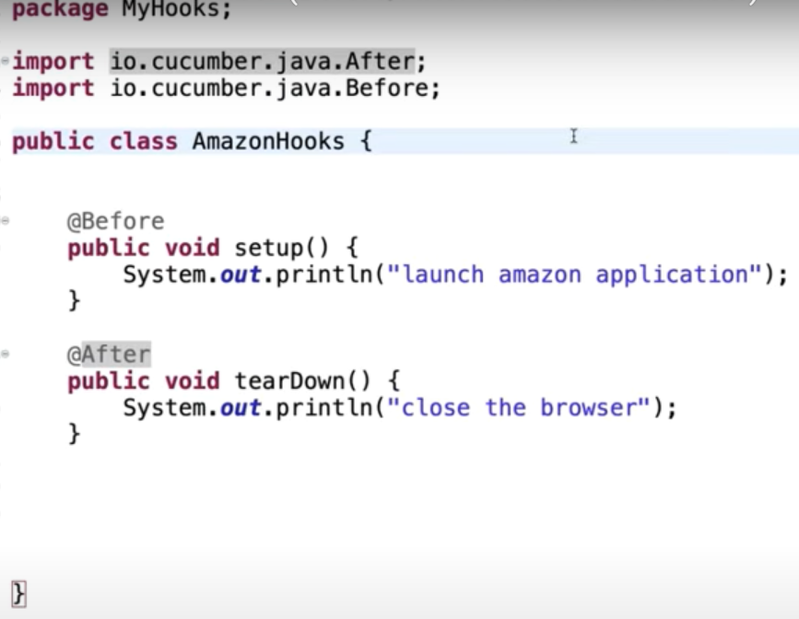 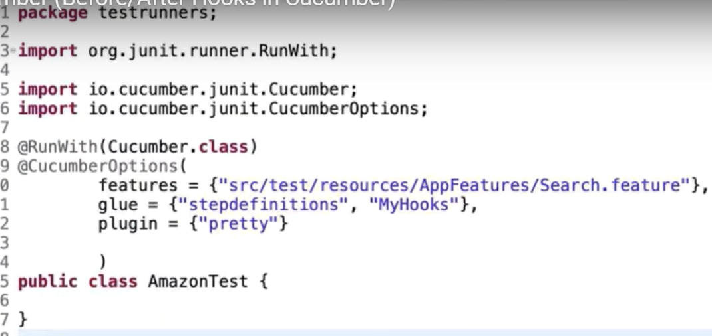
* **Important** - We can also add custom Scenario object to the Hooks and get the status and other **details about the scenario** 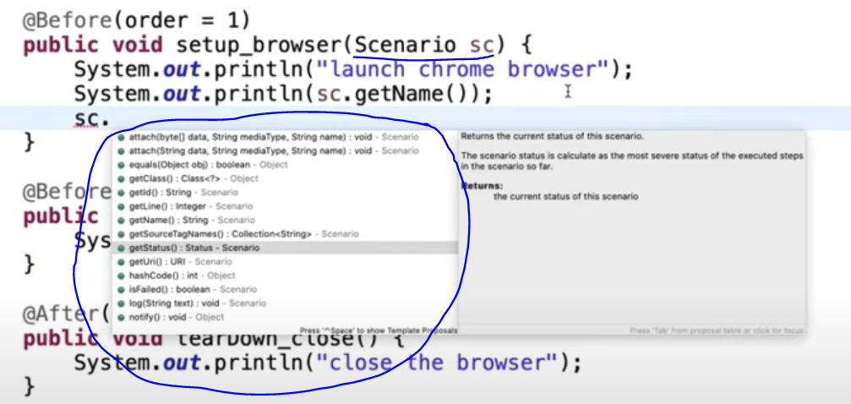
* **Tagged Hooks** gives more freedom in designing and selecting hooks to run before or after certain scenarios which are having the specific tags.

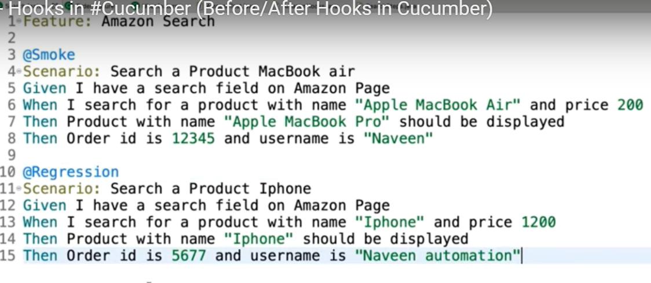

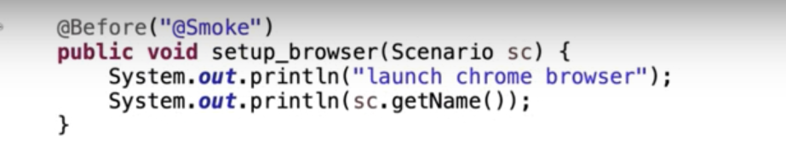 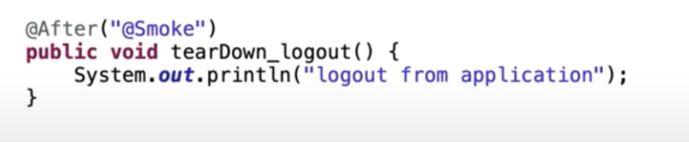

1. **Cucumber Reports**

* These are some of the reports which can be generated with Cucumber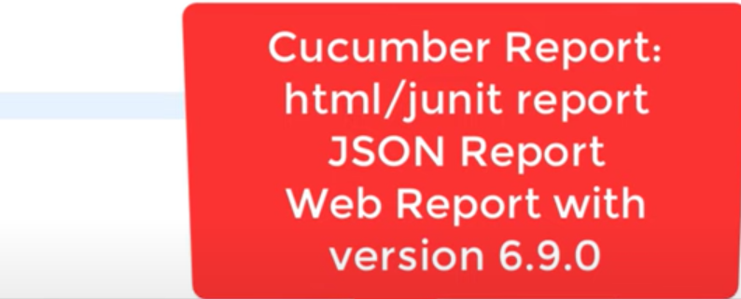
* The easiest way to format your cucumber output in console is to add “**pretty**” plugin in Runner class

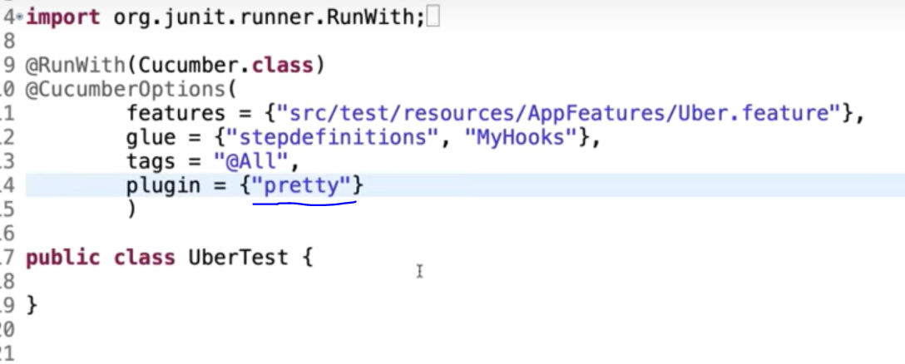 Output will be as below in console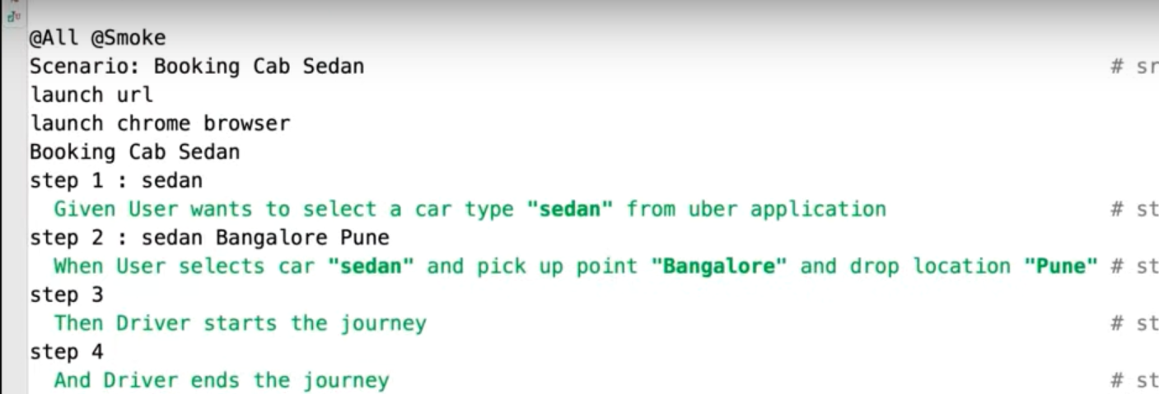

* The next option is to create a **json report and junit report**  by specifying it inside the plugin option of Runner class and also giving the path and the filename as well

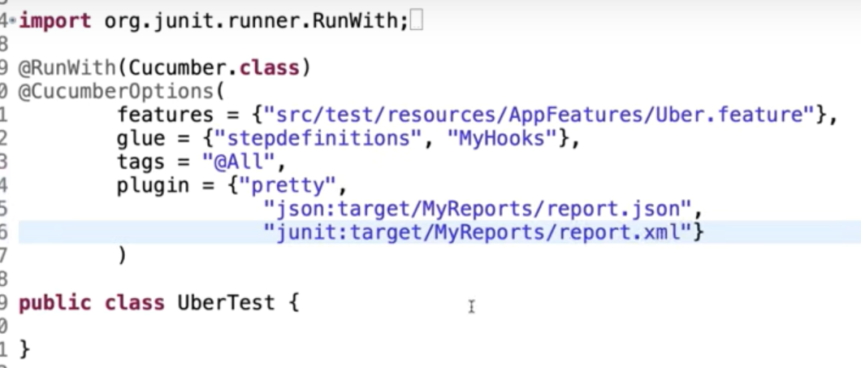

* **Cucumber Web Reports** – provides the flexibility to publish the reports in cucumber cloud. There are four ways by which the reports can be enabled

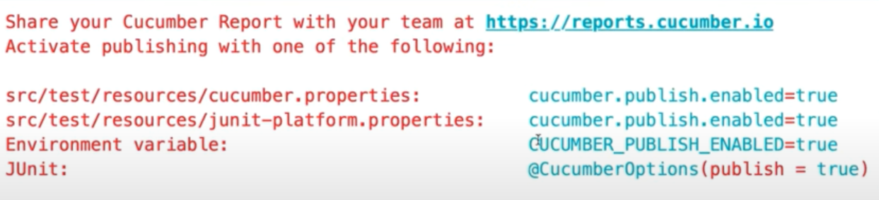

The easiest way is the fourth one where we need to add the **publish value as true** in the Runner class.

We can also create separate properties file in resources folder and enable the value as – **cucumber.publish.enabled=true**

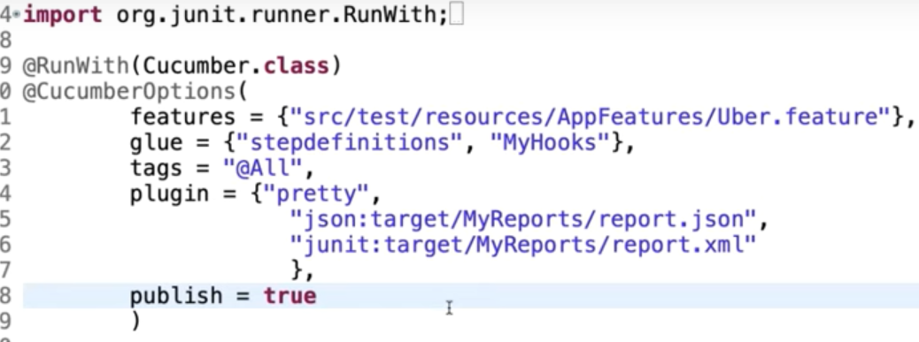

After we run the cucumber runner class as junit, then in the console we would get the link to access the results

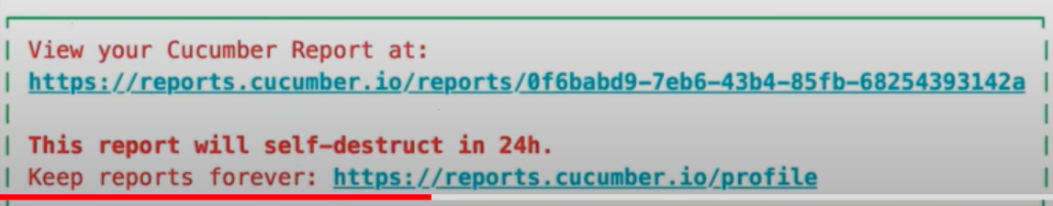

Copy the link and paste in browser to view the report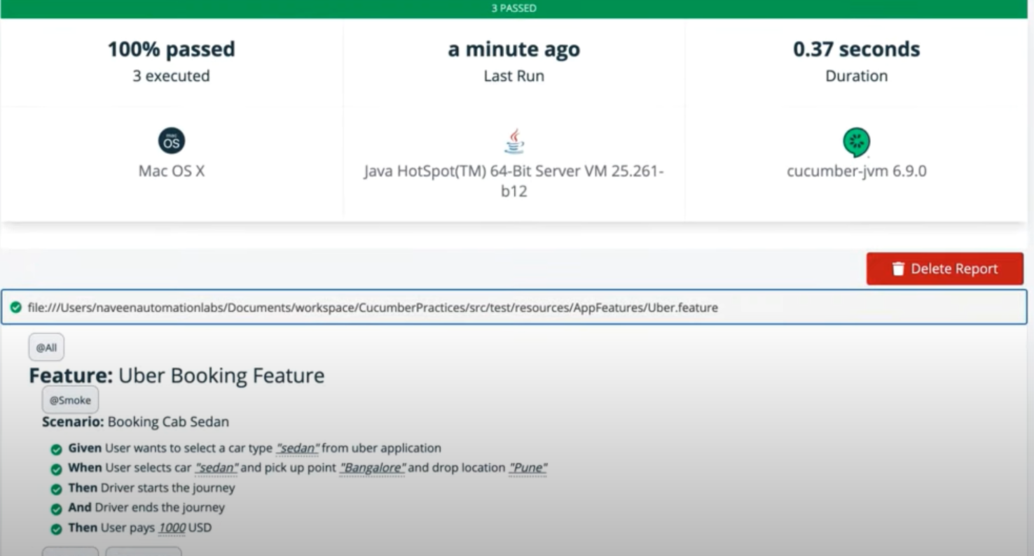

1. **DataTable in Cucumber**

* **asLists()**

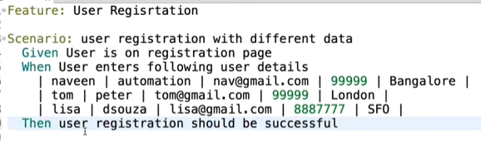

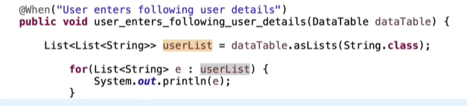

* **asMaps()**

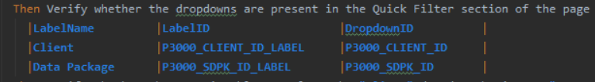

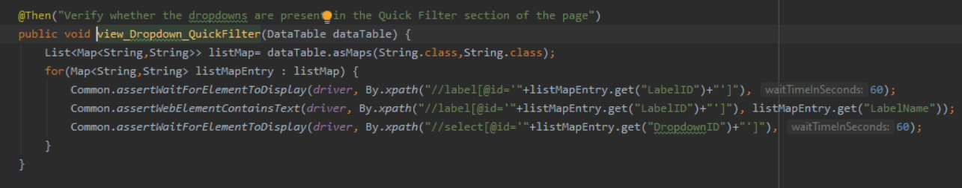

* **asList()**

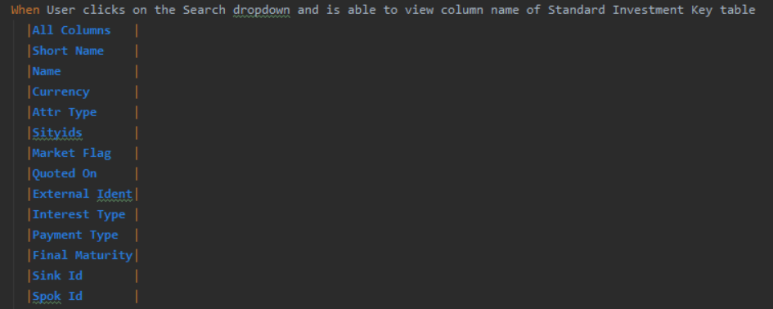

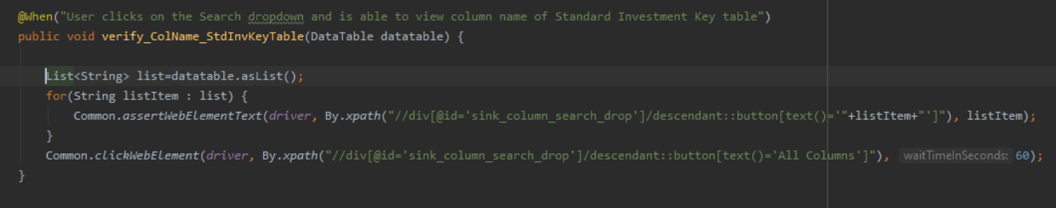

1. **Scenario Outline with Examples keyword**

* Primarily used when there are couple of test steps that needs to be repeated with different sets of test data.

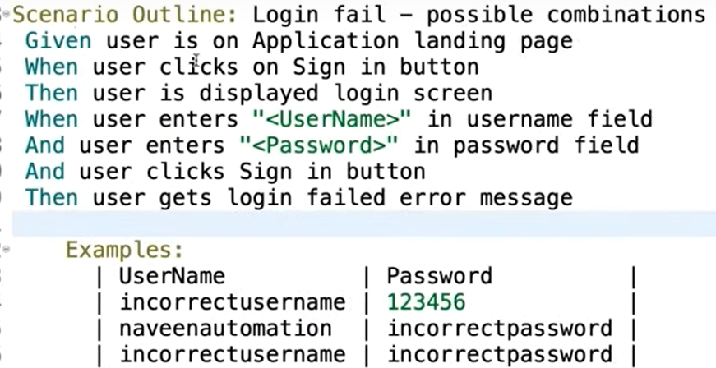

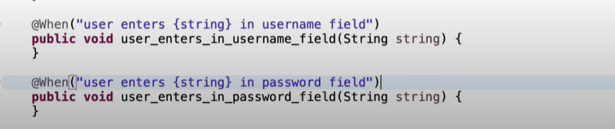

* In the above Scenario Outline the username and password are passed as **String** and hence they are marked in **double quotes in the feature file**.

“<UserName>” “<Password>”

* If the data needs to be passed in the form of any **other dataype other than String** then then the **double quotes must be avoided**

<UserName> <Password>

1. **Passing data between Cucumber steps using ‘this’ keyword**

* Sometimes there are scenarios wherein values need to be passed between steps. Such functionality can be delivered with the help of ‘this’ keyword in the step definition file.
* **Note - Passing values between steps using this keyword or instance variable can be done only inside a particular scenario or scenario outline. To pass data between different scenarios can be implemented using TestContext and ScenarioContext methods.**

[**https://www.toolsqa.com/selenium-cucumber-framework/share-data-between-steps-in-cucumber-using-scenario-context/**](https://www.toolsqa.com/selenium-cucumber-framework/share-data-between-steps-in-cucumber-using-scenario-context/)

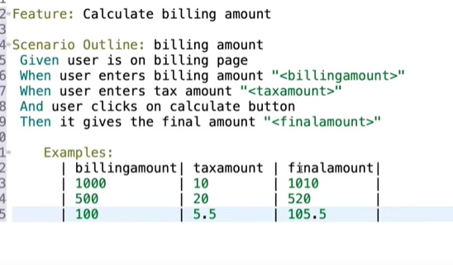

In the above feature file, the **billing amount** and **tax amount** data must be used to calculate the **final amount** value. Hence the value needs to be passed between step definitions.

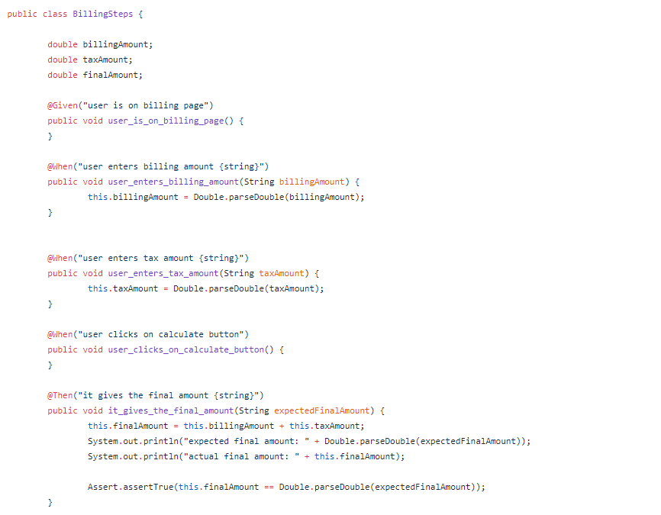

In the above step definition we can see that the 3 double instance variables have been defined as the value needs to be converted to double from String (specified in feature file) for calculation.

Then for each step which has a value to be reused, we will convert the String value into double and then assign it to the instance variable using **this keyword.**

| **Here we declare the int and double type values in the feature file as String and later convert them into their respective type in Step definition file because**   * + - https://github.com/cucumber/cucumber-jvm/issues/2183 |
| --- |

1. **Gherkin Keywords**

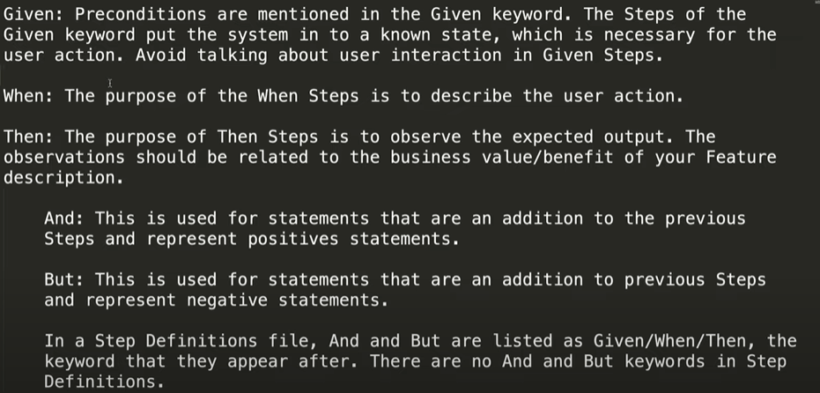

* **Given When Then** can be followed by **When and Then** to suit the purpose of the Scenario. **And** / **But** can be used to make it more readable.

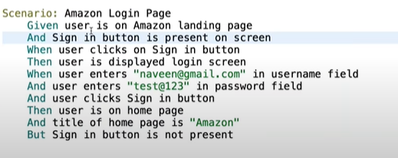

* **And** / **But** is not having separate tags in Step definition file, instead there we can use **Then** keyword.